**Overview**

Compute Engine lets you create virtual machines running different operating systems, including multiple flavors of Linux (Debian, Ubuntu, Suse, Red Hat, CoreOS) and Windows Server, on Google infrastructure. You can run thousands of virtual CPUs on a system that has been designed to be fast and to offer strong consistency of performance.

In this hands-on lab you'll learn how to create virtual machine instances of various machine types using the Google Cloud Console and using the gcloud command line. You'll also learn how to connect an NGINX web server to your virtual machine.

Although you can easily copy and paste commands from the lab to the appropriate place, students should type the commands themselves to reinforce their understanding of the core concepts

**What you'll do**

* Create a virtual machine with the Cloud Console
* Create a virtual machine with gcloud command line
* Deploy a web server and connect it to a virtual machine

Prerequisites

* Familiarity with standard Linux text editors such as vim, emacs, or nano will be helpful

**Setup**

**Before you click the Start Lab button**

Read these instructions. Labs are timed and you cannot pause them. The timer, which starts when you click **Start Lab**, shows how long Google Cloud resources will be made available to you.

This Qwiklabs hands-on lab lets you do the lab activities yourself in a real cloud environment, not in a simulation or demo environment. It does so by giving you new, temporary credentials that you use to sign in and access Google Cloud for the duration of the lab.

**What you need**

To complete this lab, you need:

* Access to a standard internet browser (Chrome browser recommended).
* Time to complete the lab.

**Note:** If you already have your own personal Google Cloud account or project, do not use it for this lab.

**Note:** If you are using a Pixelbook, open an Incognito window to run this lab.

**How to start your lab and sign in to the Google Cloud Console**

1. Click the **Start Lab** button. If you need to pay for the lab, a pop-up opens for you to select your payment method. On the left is a panel populated with the temporary credentials that you must use for this lab.

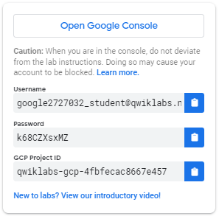

1. Copy the username, and then click **Open Google Console**. The lab spins up resources, and then opens another tab that shows the **Sign in** page.



***Tip:*** Open the tabs in separate windows, side-by-side.

If you see the **Choose an account** page, click **Use Another Account**. 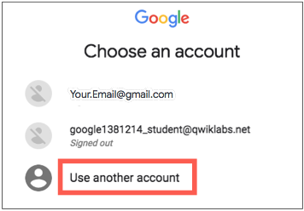

1. In the **Sign in** page, paste the username that you copied from the Connection Details panel. Then copy and paste the password.

***Important:*** You must use the credentials from the Connection Details panel. Do not use your Qwiklabs credentials. If you have your own Google Cloud account, do not use it for this lab (avoids incurring charges).

1. Click through the subsequent pages:
   * Accept the terms and conditions.
   * Do not add recovery options or two-factor authentication (because this is a temporary account).
   * Do not sign up for free trials.

After a few moments, the Cloud Console opens in this tab.

**Note:** You can view the menu with a list of Google Cloud Products and Services by clicking the **Navigation menu** at the top-left. 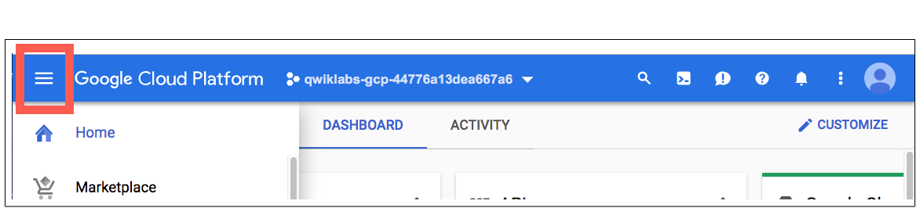

Activate Cloud Shell

Cloud Shell is a virtual machine that is loaded with development tools. It offers a persistent 5GB home directory and runs on the Google Cloud. Cloud Shell provides command-line access to your Google Cloud resources.

In the Cloud Console, in the top right toolbar, click the **Activate Cloud Shell** button.

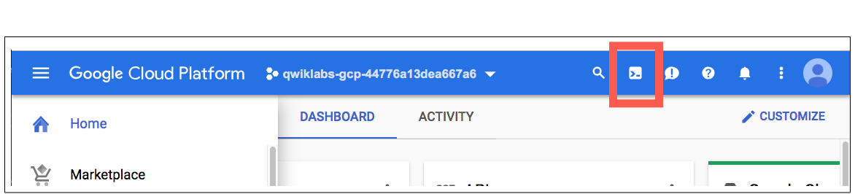

Click **Continue**.

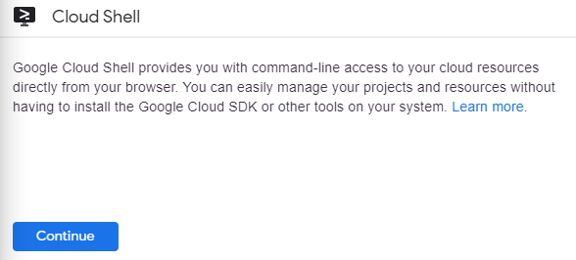

It takes a few moments to provision and connect to the environment. When you are connected, you are already authenticated, and the project is set to your *PROJECT_ID*. For example:

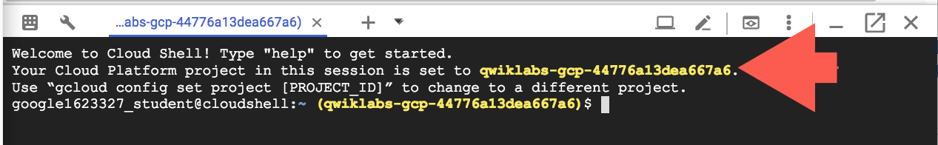

gcloud is the command-line tool for Google Cloud. It comes pre-installed on Cloud Shell and supports tab-completion.

You can list the active account name with this command:

gcloud auth list

(Output)

Credentialed accounts:

- <myaccount>@<mydomain>.com (active)

(Example output)

Credentialed accounts:

- google1623327_student@qwiklabs.net

You can list the project ID with this command:

gcloud config list project

(Output)

[core]

project = <project_ID>

(Example output)

[core]

project = qwiklabs-gcp-44776a13dea667a6

For full documentation of gcloud see the [gcloud command-line tool overview](https://cloud.google.com/sdk/gcloud).

Understanding Regions and Zones

Certain Compute Engine resources live in regions or zones. A region is a specific geographical location where you can run your resources. Each region has one or more zones. For example, the us-central1 region denotes a region in the Central United States that has zones us-central1-a, us-central1-b, us-central1-c, and us-central1-f.

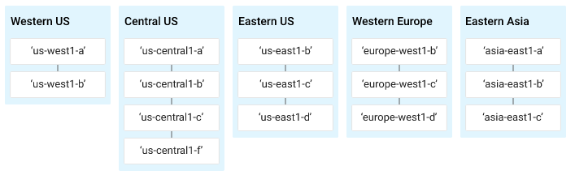

Resources that live in a zone are referred to as zonal resources. Virtual machine Instances and persistent disks live in a zone. To attach a persistent disk to a virtual machine instance, both resources must be in the same zone. Similarly, if you want to assign a static IP address to an instance, the instance must be in the same region as the static IP.

Learn more about regions and zones and see a complete list in [Regions & Zones documentation](https://cloud.google.com/compute/docs/regions-zones/).

**Create a new instance from the Cloud Console**

In this section, you'll learn how to create new pre-defined machine types with Compute Engine from the Cloud Console.

In the Cloud Console, on the top left of the screen, select **Navigation menu** > **Compute Engine** > **VM Instances**:

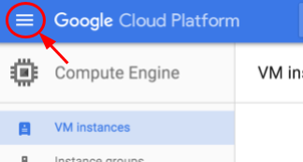

This may take a minute to initialize for the first time.

To create a new instance, click **Create**.

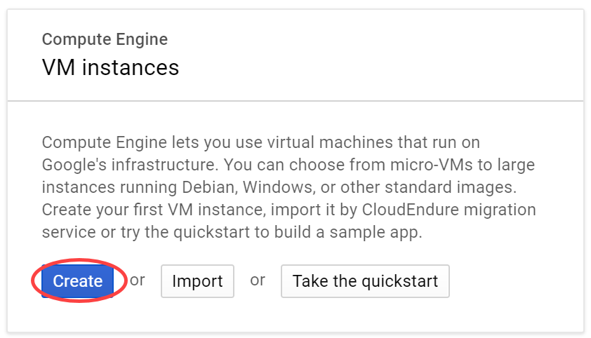

There are many parameters you can configure when creating a new instance. Use the following for this lab:

|  |  |  |
| --- | --- | --- |
| **Field** | **Value** | **Additional Information** |
| **Name** | gcelab | Name for the VM instance |
| **Region** | us-central1 (Iowa) | Learn more about regions in [Regions & Zones documentation](https://cloud.google.com/compute/docs/zones). |
| **Zone** | us-central1-c  **Note:**remember the zone that you selected, you'll need it later. | Learn more about zones in [Regions & Zones documentation](https://cloud.google.com/compute/docs/zones). |
| **Series** | N1 | Name of the series |
| **Machine Type** | 2 vCPUs  This is a (n1-standard-2),  2-CPU, 7.5GB RAM instance.  There are a number of machine types, ranging from micro instance types to 32-core/208GB RAM instance types. Learn more in the [Machine Types documentation](https://cloud.google.com/compute/docs/machine-types). | **Note**: A new project has a default [resource quota](https://cloud.google.com/compute/docs/resource-quotas), which may limit the number of CPU cores. You can request more when you work on projects outside of this lab. |
| **Boot Disk** | New 10 GB standard persistent disk  OS Image: Debian GNU/Linux 9 (stretch) | There are a number of images to choose from, including: Debian, Ubuntu, CoreOS as well as premium images such as Red Hat Enterprise Linux and Windows Server. See Operating System documentation for more detail. |
| **Firewall** | Check Allow HTTP traffic  Check this option so to access a webserver that you'll install later. | **Note:**This will automatically create firewall rule to allow HTTP traffic on port 80. |

Click **Create**.

Wait for it to finish - it shouldn't take more than a minute.

Once finished, you should see the new virtual machine in the **VM Instances** page.

To SSH into the virtual machine, click on **SSH** on the right hand side. This launches a SSH client directly from your browser.

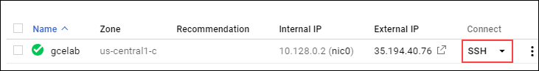

**Note:** For more information, see the [Connect to an instance using ssh documentation](https://cloud.google.com/compute/docs/instances/connecting-to-instance).

Install a NGINX web server

Now you'll install NGINX web server, one of the most popular web servers in the world, to connect your virtual machine to something.

Once SSH'ed, get root access using sudo:

sudo su -

As the root user, update your OS:

apt-get update

(Output)

Get:1 http://security.debian.org stretch/updates InRelease [94.3 kB]

Ign http://deb.debian.org strech InRelease

Get:2 http://deb.debian.org strech-updates InRelease [91.0 kB]

...

Install NGINX:

apt-get install nginx -y

(Output)

Reading package lists... Done

Building dependency tree

Reading state information... Done

The following additional packages will be installed:

...

Check that NGINX is running:

ps auwx | grep nginx

(Output)

root 2330 0.0 0.0 159532 1628 ? Ss 14:06 0:00 nginx: master process /usr/sbin/nginx -g daemon on; master_process on;

www-data 2331 0.0 0.0 159864 3204 ? S 14:06 0:00 nginx: worker process

www-data 2332 0.0 0.0 159864 3204 ? S 14:06 0:00 nginx: worker process

root 2342 0.0 0.0 12780 988 pts/0 S+ 14:07 0:00 grep nginx

Awesome! To see the web page, go to the Cloud Console and click the External IP link of the virtual machine instance. You can also see the web page by adding the External IP to http://EXTERNAL_IP/ in a new browser window or tab.

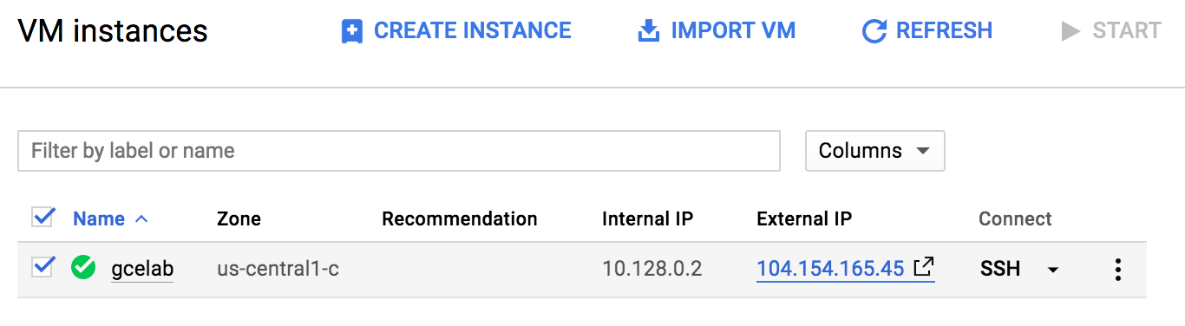

You should see this default web page:

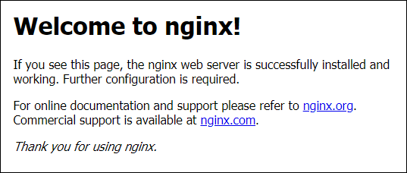

To check your progress in this lab, click **Check my progress** below. A checkmark means you're on track.

Create a Compute Engine instance and add Nginx Server to your instance with necessary firewall rules.

Check my progress

**Create a new instance with gcloud**

Rather than using the Cloud Console to create a virtual machine instance, you can use the command line tool gcloud, which is pre-installed in [Google Cloud Shell](https://cloud.google.com/developer-shell/#how_do_i_get_started). Cloud Shell is a Debian-based virtual machine loaded with all the development tools you'll need (gcloud, git, and others) and offers a persistent 5GB home directory.

If you want to try this on your own machine in the future, read the [gcloud command line tool guide](https://cloud.google.com/sdk/gcloud/).

In the Cloud Shell, create a new virtual machine instance from the command line using gcloud:

gcloud compute instances create gcelab2 --machine-type n1-standard-2 --zone us-central1-c

(Output)

Created [...gcelab2].

NAME ZONE MACHINE_TYPE ... STATUS

gcelab2 us-central1-c n1-standard-2 ... RUNNING

Click **Check my progress** below to verify you're on track in this lab.

Create a new instance with gcloud.

Check my progress

The instance created has these default values:

* The latest [Debian 9 (stretch)](https://cloud.google.com/compute/docs/images#debian) image.
* The n1-standard-2 [machine type](https://cloud.google.com/compute/docs/machine-types). In this lab you can select one of these other machine types if you'd like: n1-highmem-4 or n1-highcpu-4. When you're working on a project outside of Qwiklabs, you can also specify a [custom machine type](https://cloud.google.com/compute/docs/instances/creating-instance-with-custom-machine-type).
* A root persistent disk with the same name as the instance; the disk is automatically attached to the instance.

Run gcloud compute instances create --help to see all the defaults.

**Note:**You can set the default region and zones that gcloud uses if you are always working within one region/zone and you don't want to append the --zone flag every time. Do this by running these commands :

gcloud config set compute/zone ...

gcloud config set compute/region ...

To exit help, press **Ctrl**+**c**.

Check out your instances. Select **Navigation menu** > **Compute Engine** > **VM instances**. You should see the 2 instances you created in this lab.

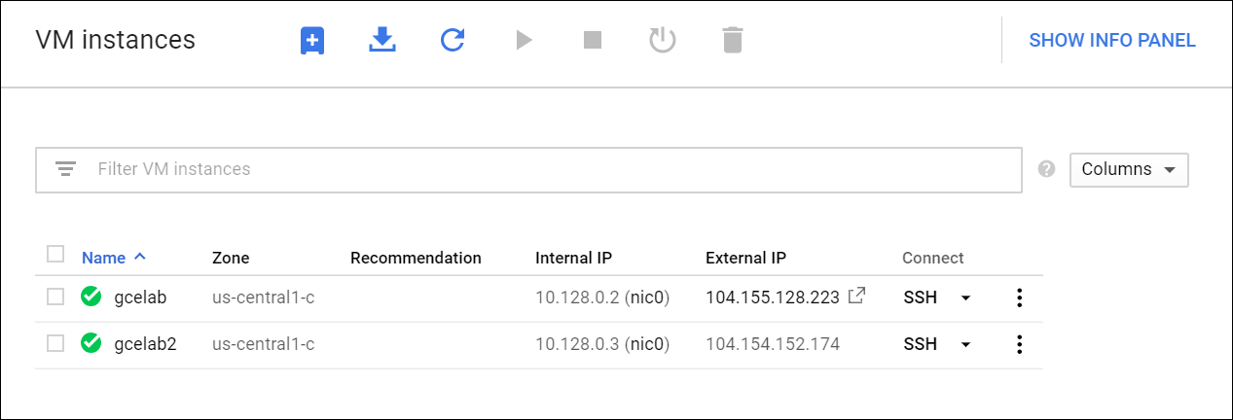

Finally, you can SSH into your instance using gcloud as well. Make sure you add your zone, or omit the --zone flag if you've set the option globally:

gcloud compute ssh gcelab2 --zone us-central1-c

(Output)

WARNING: The public SSH key file for gcloud does not exist.

WARNING: The private SSH key file for gcloud does not exist.

WARNING: You do not have an SSH key for gcloud.

WARNING: [/usr/bin/ssh-keygen] will be executed to generate a key.

This tool needs to create the directory

[/home/gcpstaging306_student/.ssh] before being able to generate SSH

Keys.

Now you'll type **Y** to continue.

Do you want to continue? (Y/n)

**Enter** through the passphrase section to leave the passphrase empty.

Generating public/private rsa key pair.

Enter passphrase (empty for no passphrase)

After connecting, you disconnect from SSH by exiting from the remote shell:

exit

**Test your knowledge**

Test your knowledge about Google Cloud by taking our quiz. (Please select multiple correct options if necessary.)

Through which of the following ways you can create a VM instance in Compute Engine(Compute Engine)?

checkThe gcloud command line tool.

checkThrough web console.

Submit

**Congratulations!**

Compute Engine is the foundation to Google Cloud's Infrastructure-as-a-Service. You created a virtual machine with Compute Engine and can now map your existing server infrastructure, load balancers, and network topology to Google Cloud.



Finish Your Quest

This self-paced lab is part of the Qwiklab [Google Cloud Essentials](https://google.qwiklabs.com/quests/23) Quest. A Quest is a series of related labs that form a learning path. Completing a Quest earns you a badge to recognize your achievement. You can make your badge (or badges) public and link to them in your online resume or social media account. [Enroll in this Quest](https://google.qwiklab.com/learning_paths/23/enroll) and get immediate completion credit if you've taken this lab. [See other available Qwiklabs Quests](https://google.qwiklabs.com/catalog).

**Take Your Next Lab**

Continue your Quest with [Getting Started with Cloud Shell & gcloud](https://google.qwiklabs.com/catalog_lab/320), or check out these suggestions:

* [Getting Started with Cloud Shell & gcloud](https://google.qwiklabs.com/catalog_lab/320)
* [Provision Services with Google Cloud Marketplace](https://google.qwiklabs.com/catalog_lab/339)